Available CROSS COUNTRY certificates, pricing, options, etc.
(to be used when filling out order form)

Code | Description | Code | Description
CC-1 | Most Valuable Runner | CC-11 | Most Individual Wins
CC-2 | Freshman of the Year | CC-12 | Team Manager Award
CC-3 | Sophomore of the Year | CC-13 | Nervous Runner Award
CC-4 | Junior of the Year | CC-14 | Scholar-Athlete Award
CC-5 | Senior of the Year | CC-15 | Most Dedicated Runner
CC-6 | Coach’s Award (This is for a runner) | CC-16 | Assistant Coach Award
CC-7 | Most Improved Runner Award | CC-17 | Other (you tell us)
CC-8 | Team Captain Award | CC-18 | Certificate of Participation
CC-9 | Best Come From Behind Win | CC-19 | Team Roster Award (use separate form)
CC-10 | Hardest Worker Award

All above awards can have personal season-best times or any other stats on the award (write next to name on back of order form)

Available Cross Country Graphics:
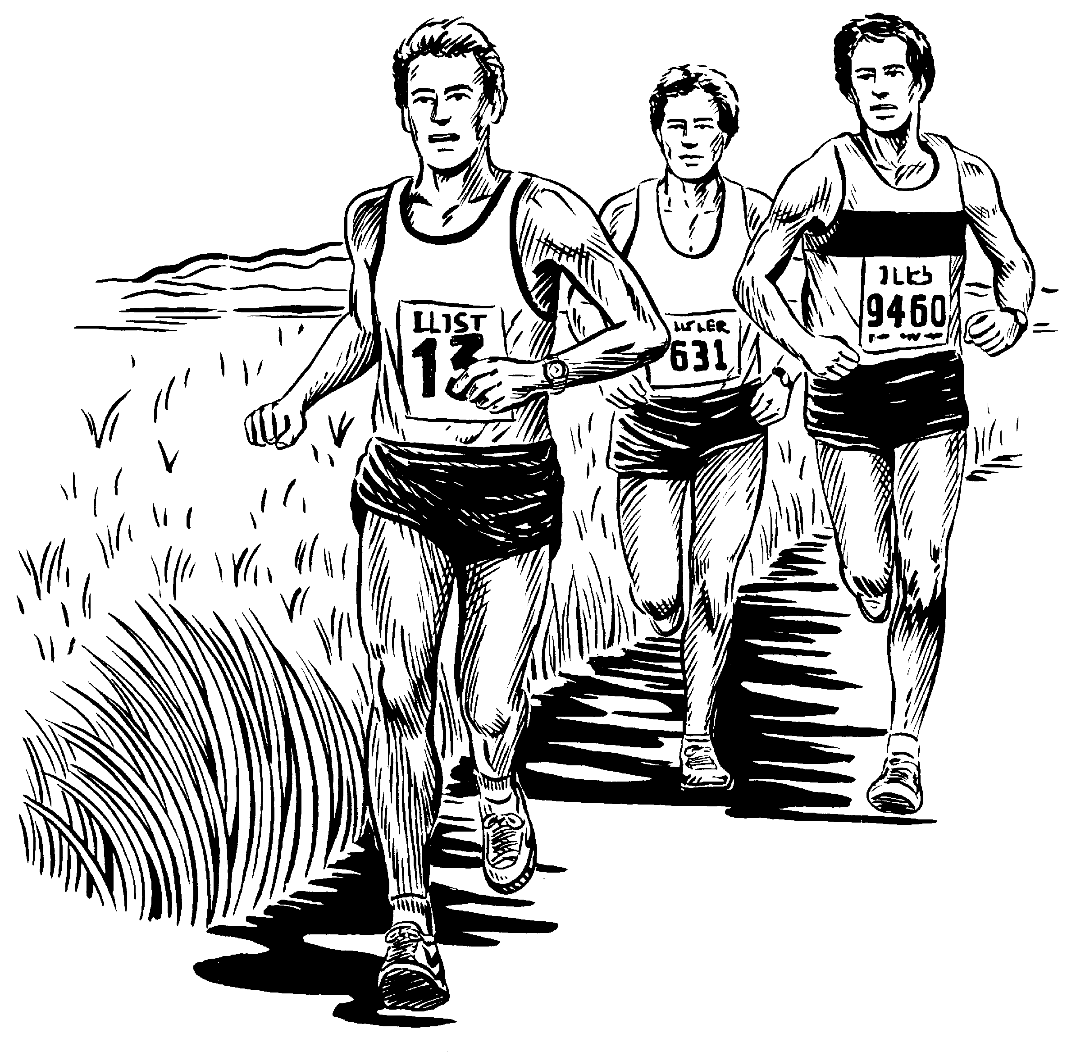 |  | 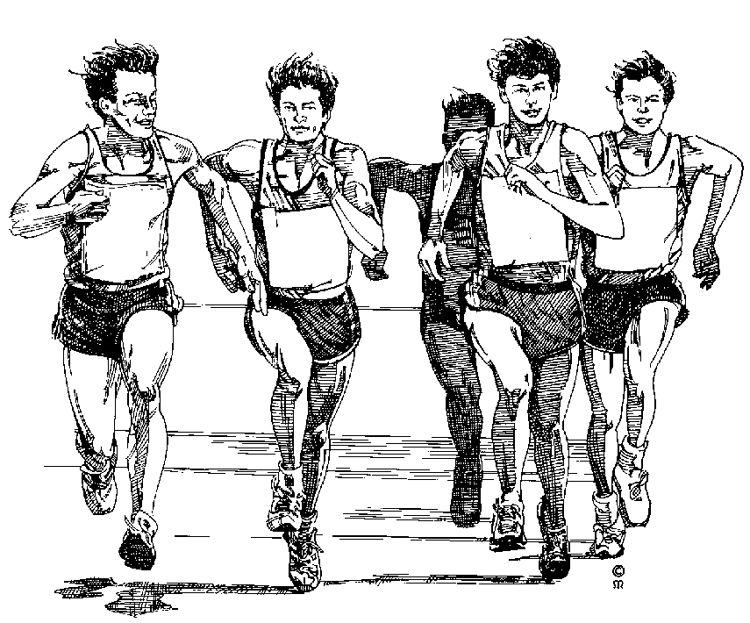 | 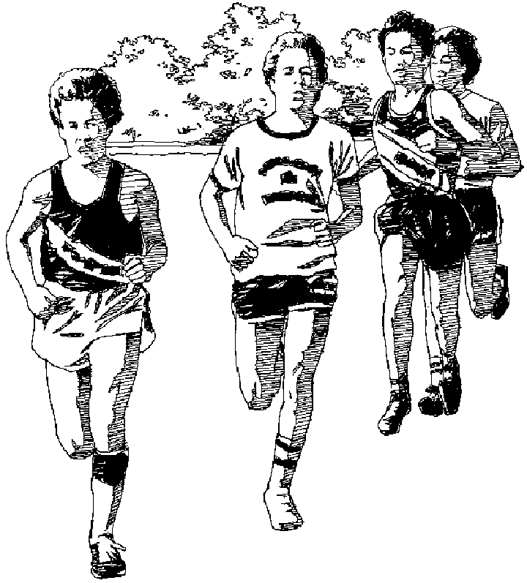
CCB1 (Single Color)  3 Male Runners – All Caucasian | CCB2 (Single Color)  4 Male Runners – 2 Afro-American | CCB3 (Single Color)  5 Male Runners | CCB4 (Single Color)  4 Male Runners

 | 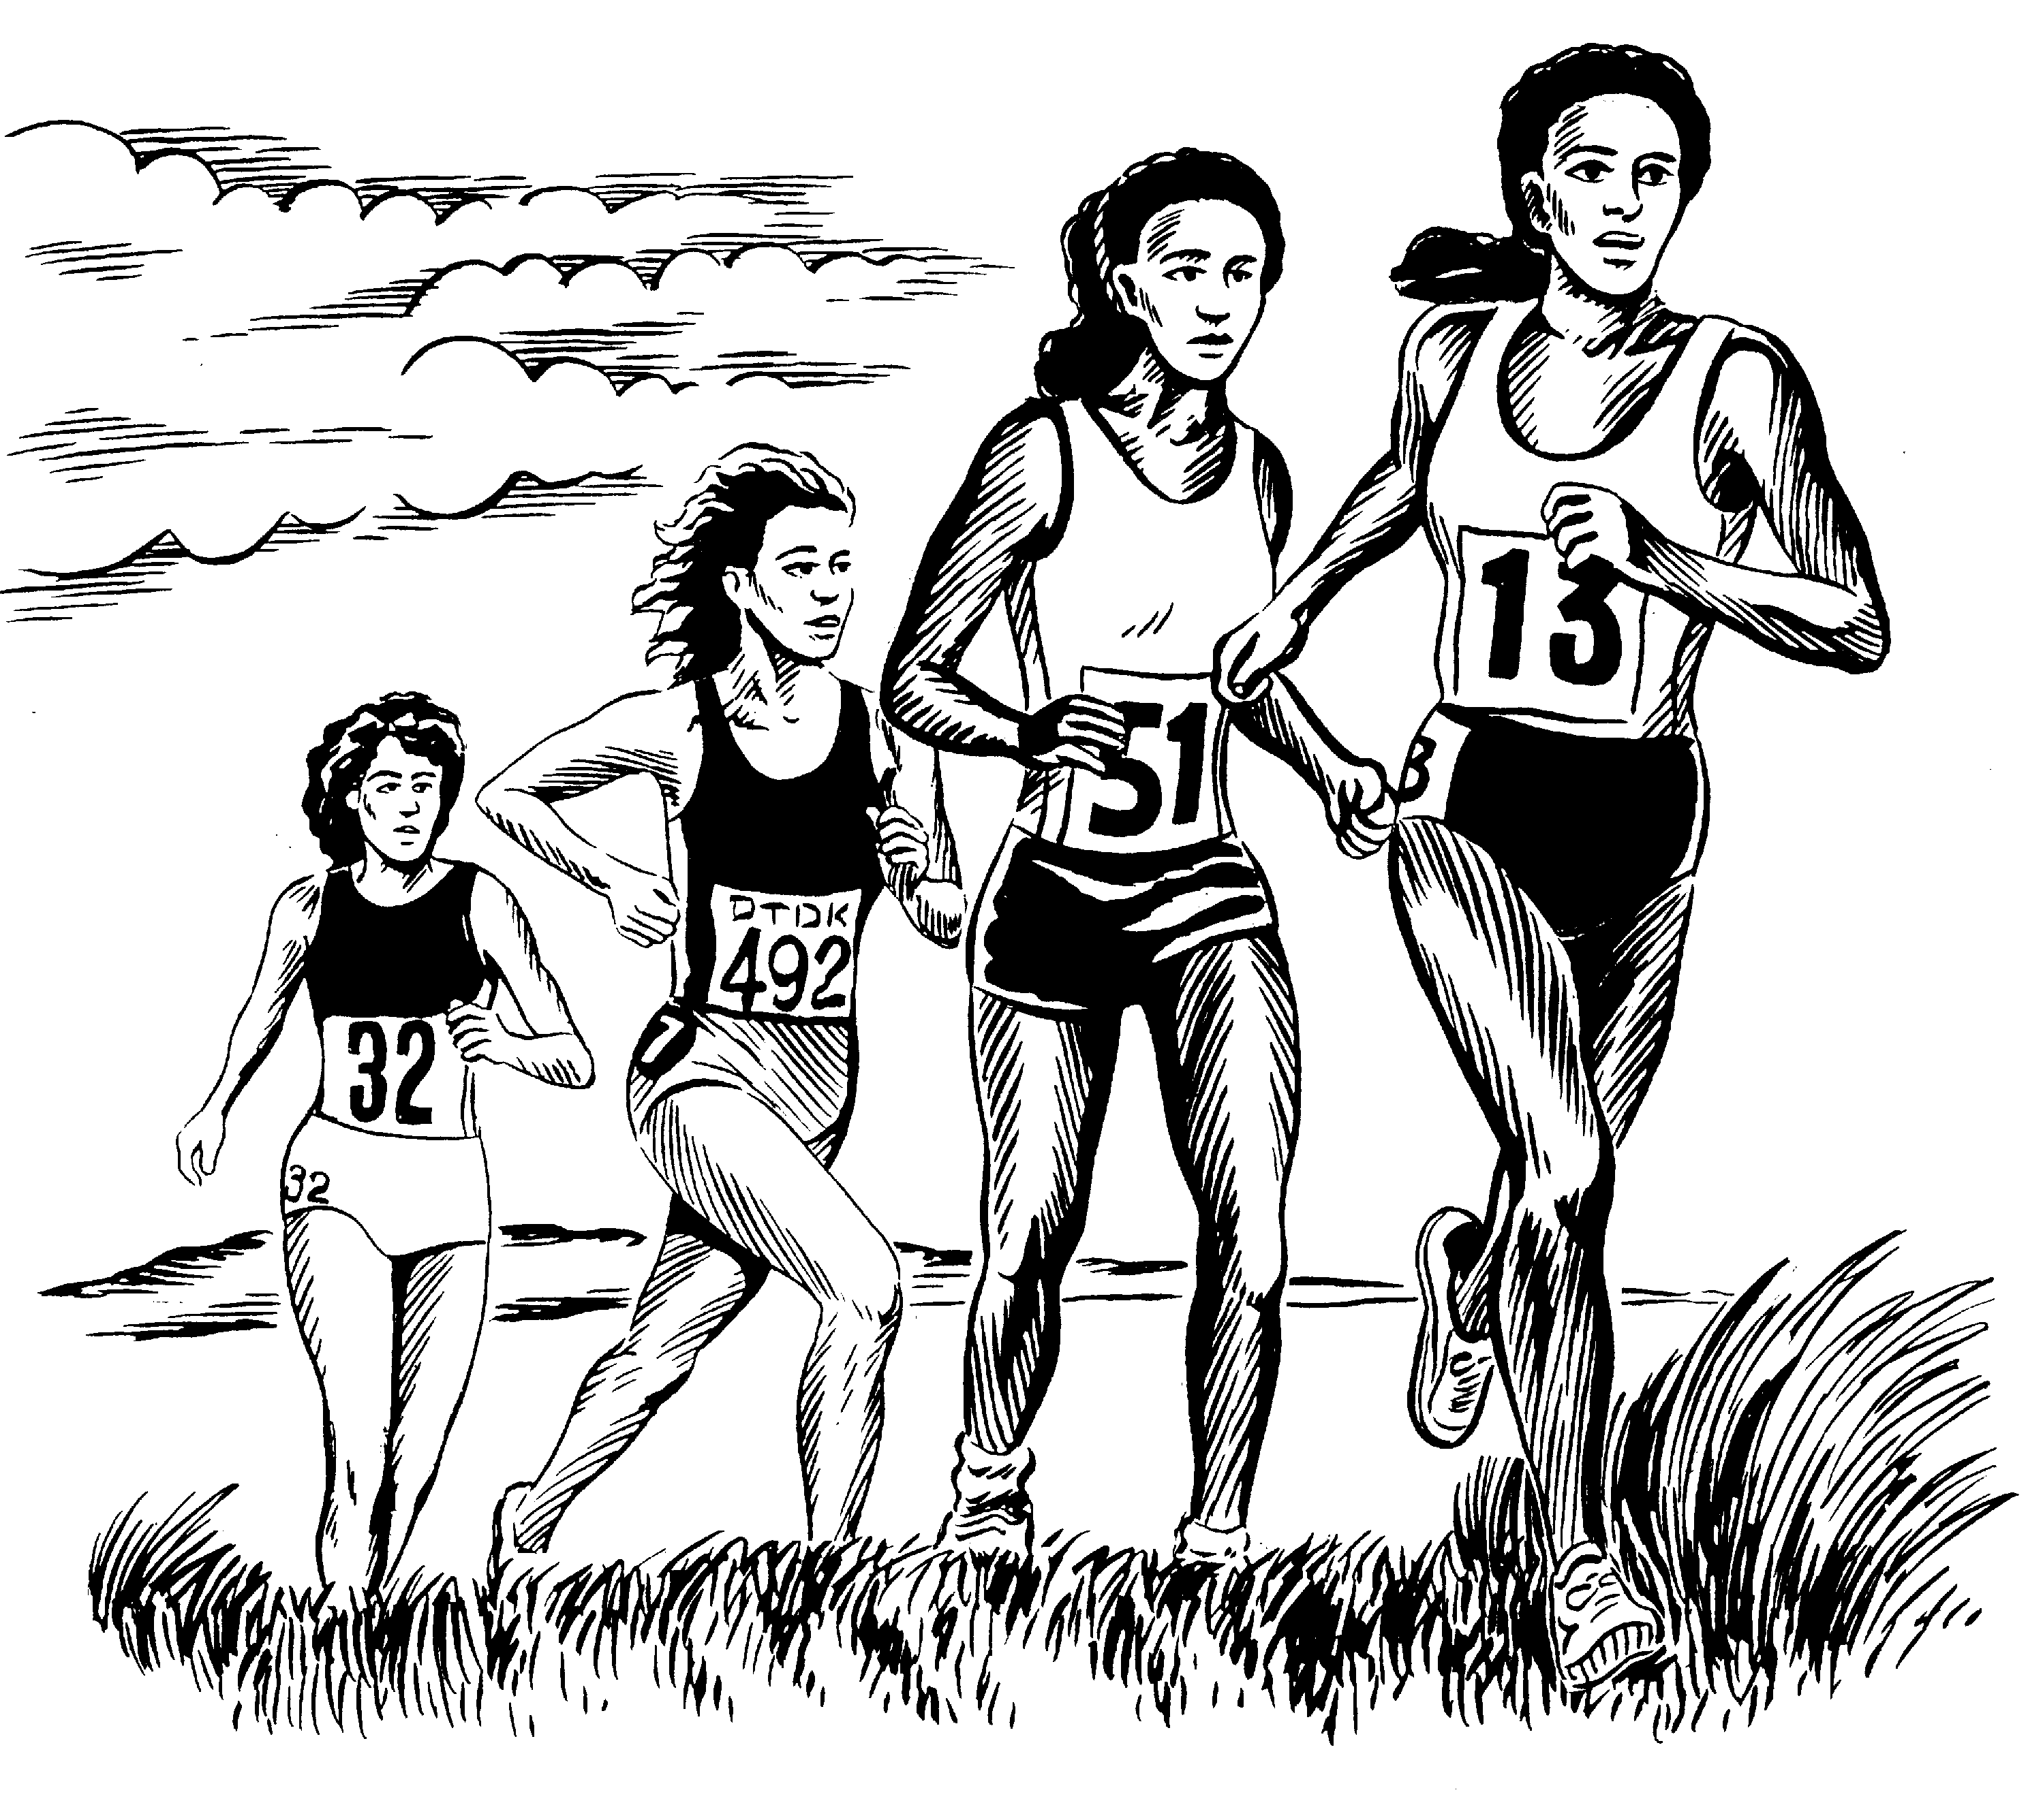
CCG1 (Single Color)  3 Female Runners – All Caucasian | CCG2 (Single Color)  4 Female Runners – 2 Afro-American

PRICING OF CERTIFICATES STYLE “A” (See options sheet)
Description | *Base Price | Single Color Graphic | Full Color Graphic | Mascot or  Logo | Athlete Name | Total  (All Options)
CC-1 thru CC-16 | $ 1.50 each | Included | N/A | Add $ .25 | Add $ .25 | $ 2.00 each
CC-17 (Special order) | $ 1.75 each | Included | N/A | Add $ .25 | Add $ .25 | $ 2.25 each
CC-18 (Participation) | $ 1.35 each | Included | N/A | Add $ .25 | Add $ .25 | $ 1.85 each

*Base Price includes choice of border color, seal, color scheme, additional writing, and single color graphic.

PRICING OF CERTIFICATES STYLE “B” & “C” (See options sheet)
Description | *Base Price | Mascot or Logo | Athletic Tail | Single Color Graphic | Full Color Graphic | Embossed Seal | Athlete Name | Total  All Options
CC-1 thru CC-16 | $ 1.60 each | Included | Included | Included | N/A | Add $ .20 | Add $ .25 | $ 2.05 each
CC-17 (Special order) | $ 1.85 each | Included | Included | Included | N/A | Add $ .20 | Add $ .25 | $ 2.30 each
CC-18 (Participation) | $ 1.45 each | Included | Included | Included | N/A | Add $ .20 | Add $ .25 | $ 1.90 each

*Base Price includes choice of border color, color scheme, additional writing, mascot/logos, athletic tail.

There is a one time $15.00 setup for your mascot or logo. Athletic Tails designed for $5.00 (one time setup

